UMass Lowell – Dept. of C.S.

COMP.3090 – Database I

Student: Phong Vo – ID: 01790283

**Homework 1**

**Exercise 2.3.1**

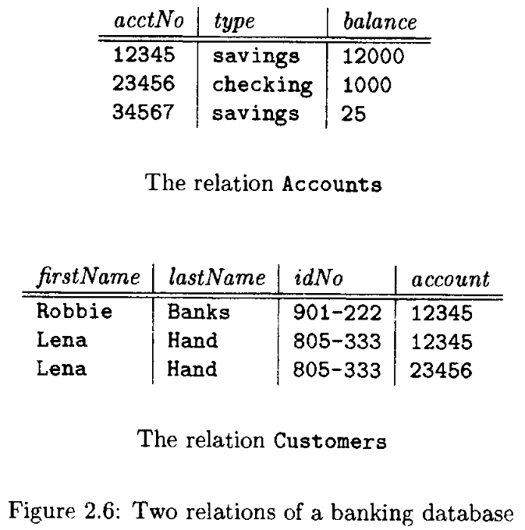

**Exercise 2.3.1**

